Scenario: check windowhandles
Step: Launch "WindowHandlePage" WebPage - PASS
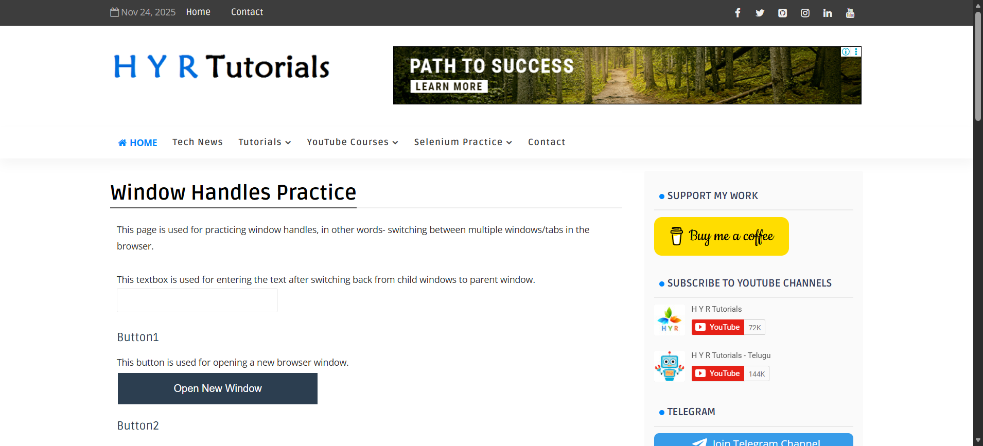
Step: User click the "Window_Button" element at "WHPage" page - PASS
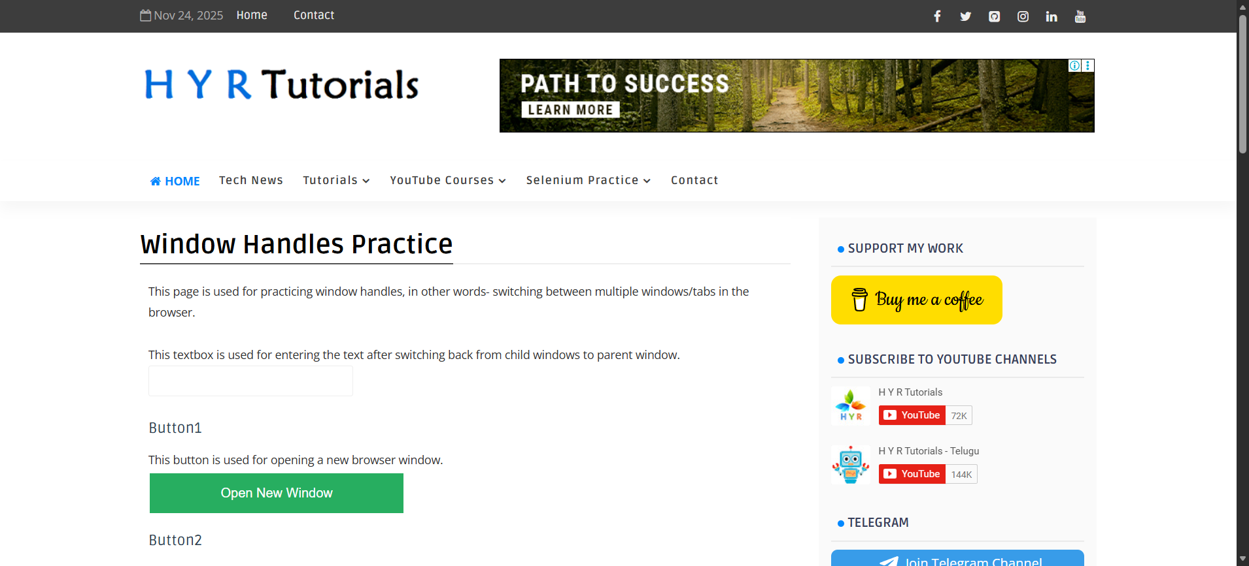
Step: And the user validate the page title with"expired.badssl.com" - FAIL
Execution Summary:
Total Steps: 3
Passed: 2
Failed: 1

